**Oxidation behavior of double-ceramic-layer thermal barrier coatings deposited by atmospheric plasma spraying and suspension plasma spraying**

Yuxiang Zhao1, Xiaochao Jin1, Denise Koch2, Robert Vaßen2, Yao Chen1, Xueling Fan1

1 Joint Research Center for Extreme Environment and Protection Technology, School of Aerospace Engineering, Xi'an Jiaotong University, Xi'an, 710049, China

2 Forschungszentrum Jülich GmbH, Institute of Energy and Climate Research IEK-1,

52425 Jülich, Germany

**Abstract**: This paper focuses on the oxidation behavior of novel double-ceramic-layer thermal barrier coatings (DCL TBCs) deposited by atmospheric plasma spraying (APS) and suspension plasma spraying (SPS). Four kinds of APS-SPS DCL TBCs with dense/porous columnar structured or vertically cracked microstructures were prepared. The oxidation behavior of the APS-SPS DCL TBCs were tested and the underlying mechanisms were further discussed. Results showed that the developed APS-SPS DCL TBCs have a better oxidation resistance than the single layer SPS TBC that was tested in comparison. In the long-term oxidation, the thermally grown oxide (TGO) can be divided into two layers, the outer mixed oxide and inner Al2O3 layer, in which the growth rate of mixed oxide in TGO changed during oxidation. In terms of the oxidation rate and oxidation lifetime, segmented APS-SPS TBCs has a slightly better performance than the columnar APS-SPS TBCs. Among the four different APS-SPS TBCs, the segmented dense APS-SPS TBCs with low vertical crack density appears to have more potential to be used for industrial application.

**Keywords：**DCL TBCs, atmospheric plasma spraying, suspension plasma spraying, oxidation, lifetime

1. **Introduction**

Thermal barrier coatings (TBCs) are widely used in aero engines and gas turbines to protect hot-section components. With the application of TBCs, the service temperature of advanced aero engines can even be higher than the melting point of the metal, thereby achieving a higher thrust-to-weight ratio and better efficiency [1-3]. State-of-the-art TBCs with a thickness of 200-400μm can reduce the temperature of the superalloy surface of the hot-section components by about 100 ℃ [4]. Traditional TBCs consist of a thermal insulating ceramic top coat and an oxidation resistant metallic bond coat. During use, a thin layer of thermally grown oxide (TGO) forms between the top coat and the bond coat. In most cases, the top coat is made of Y2O3-stabilized ZrO2 (YSZ), in which the addition of 7–8 wt.% (∼4–4.5 mol%) of Y2O3 stabilizes the non-transformable tetragonal phase (t’) at high temperature [3]. The commonly used deposition methods for thermal barrier coatings are the atmosphere plasma spraying (APS) and the electron beam-physical vapor deposition (EB-PVD). In recent years, a new spraying method, suspension plasma spraying (SPS), has been widely investigated because of its potential to combine the advantages of APS and EB-PVD [5-6], such as high stress tolerance, lower cost, lower thermal conductivity [7-11], better impact and corrosion resistance [12-13]. SPS is one of the most promising spraying methods to prepare TBCs.

As the gas temperature in front of the turbine continues to increase, traditional TBCs can no longer meet the demand. Advanced double-ceramic-layer thermal barrier coatings (DCL TBCs), with the tough YSZ on the bond coat and high temperature stable oxides on top [14], have attracted a wide range of interest all over the world. The DCL TBCs have lower thermal conductivity and better high temperature resistance, and usually have a longer service life [15-17]. In most of current research, DCL TBCs are sprayed using two different materials via the same spraying process, which means that the deposition of two layers is continuous. Doleker et al. [18] studied the TGO growth and thermal cycle life of La2Zr2O7/YSZ double-ceramic-layer TBCs sprayed with EB-PVD and found that La2Zr2O7/YSZ TBCs has better oxidation resistance and longer service time in terms of TGO layer thickness. Mahade et al. [19] studied the isothermal oxidation performance of Gd2Zr2O7/YSZ multilayered TBCs sprayed with SPS at 1150 ℃. Results showed that multilayered thermal barrier coatings of Gd2Zr2O7/YSZ showed lower weight gain and TGO thickness than single layer YSZ for all exposure time. However, the introduction of new materials will aggravate thermal mismatch problems.

Recently, few research focused on spraying DCL TBCs using the same material via different methods has been reported. In the new TBCs, a YSZ sub-layer was deposited by APS first, and then a YSZ top layer was deposited by SPS [20-21]. Compared with the single YSZ TBC deposited by SPS which exhibited premature failures before the TGO reaching a large thickness [7], thermal cycling burner rig test results showed that the YSZ DCL TBCs by APS-SPS have a much better performance, since the APS sub-layer is able to fill into the valley locations of bond coat and retard cracks propagation. It shows that the YSZ DCL TBCs by APS-SPS has a great potential to be used in aero engines and stationary gas turbines.

Previous investigations have shown that a good microstructure can improve the performance of TBCs. Results showed that smoother TC/BC interface or surface [22-24], higher column density [25-26], glazed [27] and a relative higher porosity [28] can extend the lifetime of the TBCs.

In this work, four kinds of APS-SPS DCL TBCs with dense/porous columnar structured and segmented microstructures have been deposited. The oxidation behavior and isothermal oxidation lifetime of the four kinds of APS-SPS DCL TBCs have been tested. In addition, the oxidation mechanisms are discussed in detail.

1. **Experiment procedures**

2.1 Materials

Superalloy substrates made of IN738 were bond coated with the high velocity oxygen fuel (HVOF) process using a Amdry 9954 CoNiCrAlY powder (Oerlikon Metco, Wohlen, Switzerland). APS-SPS thermal barrier coatings with different microstructures were sprayed on bond coated superalloy substrates by adjusting the spraying process parameters. By changing the spraying method and parameters, four kinds of APS-SPS DCL TBCs with dense/porous vertically cracked and dense/porous columnar structured microstructures were deposited. In addition, one segmented porous SPS single layer was deposited. The APS YSZ-layer on all coatings was deposited using a MultiCoat facility from Oerlikon Metco, Wohlen, Switzerland, with a three-cathode Triplex Pro 210 plasma spray gun. The SPS YSZ-layers were deposited using an Axial 3 torch from Northwest Mettech Corporation, Surrey, Canada. The solid content within the used suspension was kept at 5 wt. % for the columnar structured coatings and at 20 wt. % and 10 wt. % to produce the dense and porous vertically cracked coatings correspondingly. The higher porosity for the columnar structured coatings was achieved by increasing the standoff distance between sample and torch from 70 mm to 100 mm. For all coatings the current was set to the maximum capability of the facility which was 250 A per torch.

The microstructures of TBCs were characterized by a scanning electron microscope (SEM, SU 3500) equipped with an energy dispersive spectrometer (EDS). The thickness of each layer of TBCs was measured by ImageJ software. The average value of at least 20 data points was taken when calculating the thickness of the sub layer.

2.2 Long-term oxidation experiment

The oxidation tests were performed using a muffle furnace (GF 17Q, BOYUNTONG CO., China). To reduce the scatter, the specimens for oxidation test, with a geometry of 3×5×3.6 mm³, are cut from discs (ϕ12.5×3.6 mm³) produced in the same batch. Specimens were exposed to the air environment at a temperature of 1150 ℃ for 10, 20, 30, 50, 100, 150, and 200 h, with a heating rate of 5 ℃/min. For comparison, one segmented porous SPS single layer TBCs samples deposited by SPS were also oxidized. After tests, the specimens were naturally cooled to room temperature. For each oxidation condition, one test piece was used for each kind of APS-SPS TBCs and SPS single layer TBCs. Before the microstructure characterization, the specimens were polished by diamond grinding discs up to 3000-grit, then polished with a polishing agent, followed by an ultrasonic cleaning for 5 min.

2.3 Lifetime test of TBC in oxidizing environment

The specimens used for the lifetime test, 3×10×3.6 mm³, were also cut from pieces produced in the same batch. The specimens were oxidized at 1150 ℃ in the air environment until the TBCs failed. In the oxidation, there was no check for the first 200h, and the specimens were checked every 10h after 200h. When the peeling area of the TBCs reached 10%, the TBCs was considered to have failed.

1. **Results and discussion**

3.1 Microstructures of the APS-SPS TBCs

The microstructures of the four kinds of APS-SPS DCL TBCs are shown in the Fig. 1. The four different microstructures of the SPS layer show dense and porous columnar (a and b) and dense and porous segmented (c and d) coatings. Also, the double ceramic layer structure with the thinner APS layer on top of the bond coat is clearly visible. The thickness of each layer in different specimens is quite similar. The thicknesses of SPS and APS layer are about 300μm and 100μm, respectively, while the bond coat is about 150μm in thickness. According to the calculated results with ImageJ software, the porosities of dense and porous columnar structured SPS layer are about 5.1%, and 21.0%, respectively, while the crack densities of dense and porous vertically cracked SPS layer are approximately 4.7mm-1 and 6.2mm-1, respectively.

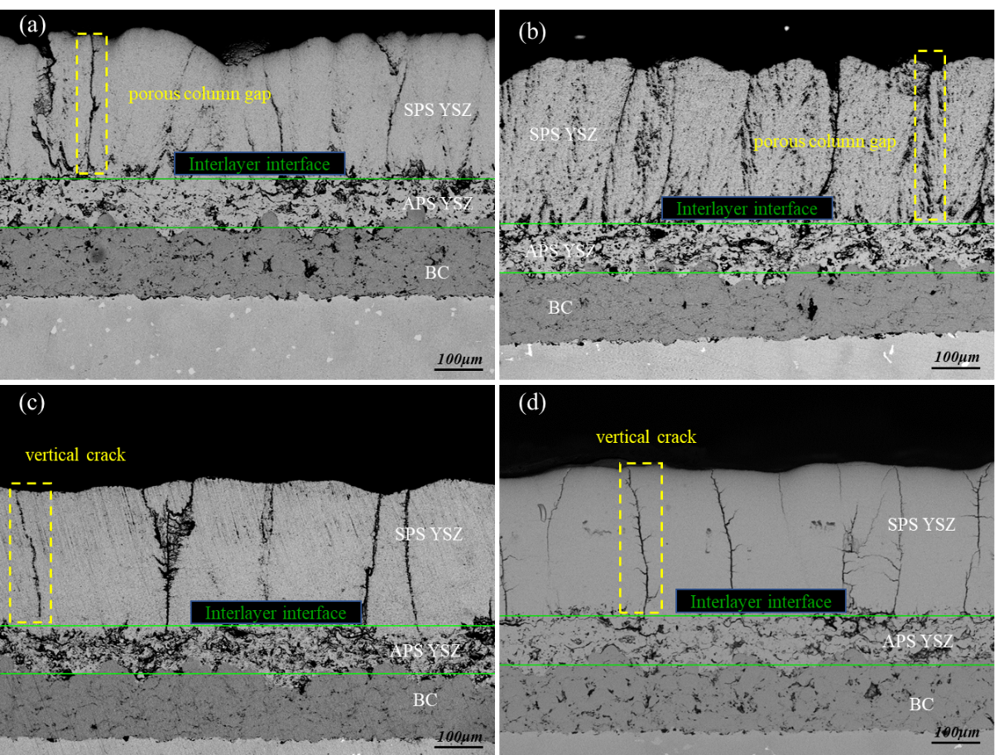

Fig. 1 As-sprayed microstructure of APS-SPS TBCs: columnar: (a) dense, (b) porous, segmented: (c) dense, (d) porous.

The double layer approach is used here, because the intermediate, highly tough APS YSZ layer can reduce crack propagation close to the interface top coat - bond coat. Here the TGO grows which introduces additional stress in the TBCs system. This stress promotes crack growth and failure and therefore a highly tough material is essential [28].

The microstructure of the segmented porous SPS TBCs is shown in the Fig. 2. The thickness of SPS layer is about 400μm, while the bond coat is about 150μm in thickness. According to the calculated results with ImageJ software, the crack densities of SPS layer is approximately 7.6mm-1.

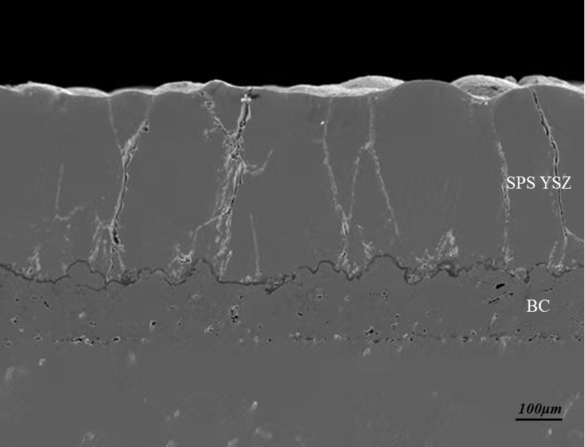

Fig. 2 Microstructure of segmented porous SPS TBCs

3.2 Evolution of the oxidation products

Different oxides form at different oxidation stages, due to the different oxygen partial pressures at the interface and the activity of the metallic species during the oxidation process. Table 1 shows the standard Gibb’s free energy and the minimum thermodynamic activity required to form oxides for the metal elements contained in the bond coat at PO2 = 1 atm and 1273 K [29-30].

**Table 1** Standard Gibb’s free energy and the minimum thermodynamic activity required to form oxides for the metal elements contained in the bond coat, at PO2 = 1 atm and 1273 K [29-30].

|  |  |  |  |  |  |
| --- | --- | --- | --- | --- | --- |
| Phase | Standard free energy of formation, ∆G° (kJ/mol) | Equilibrium constant, Ki | Thermodynamic activity of oxides, ai | Elements | Thermodynamic activity of elements, ai |
| Al2O3 | -1613.1 | 1.56×1066 | 1 | Al | 8.03×10-34 |
| Cr2O3 | -1027 | 1.39×1042 | 1 | Cr | 8.47×10-22 |
| CoO | -171.7 | 1.1×107 | 1 | Co | 3.01×10-4 |
| NiO | -192.2 | 0.77×108 | 1 | Ni | 1.14×10-4 |
| NiAl2O4 | -115.42 | - | - | - | - |
| NiCr2O4 | 158 | - | - | - | - |

Firstly, the aluminum element in the bond coat was oxidized, since the standard free energy of formation of Al2O3 is lower than others, as given in Eq. (1). Fig. 3 showed the microstructure and element distribution of the columnar porous APS-SPS TBCs that had been oxidized for 30 hours. Certainly, the resolution is not sufficient to give a quantitative picture of the concentration, however, a qualitative investigation is possible. As shown in Fig. 3, the TGO is mainly composed of alumina formed on the TC/BC interface. This is probably the stable α-Al2O3, which can hinder the diffusion of oxygen ions, as that is typically formed at this elevated temperature.

4Al+3O2=2Al2O3 (1)

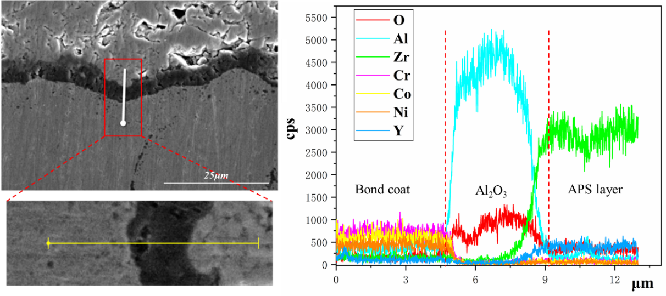

Fig. 3 The microstructure and element distribution of the columnar porous APS-SPS TBCs after 30 hours of oxidation at 1150 ℃.

Then, other elements such as Cr, Co and Ni will migrate to the oxide-gas interface, when Al content is not enough to form a continuous protective oxide film. As shown in Fig. 4, at an oxidation time of 100 hours a two layers TGO is found. The bottom layer oxide is still Al2O3, and the upper layer oxide is a mixed oxide, mainly composed of chromium, cobalt and nickel rich oxides, which often form spinel type structures [31].

Typically, this spinel type layer shows a much higher oxidation rate than the alumina layers and by the fast volume increase large stresses are introduced which lead to a fast delamination and failure of the TBCs system.

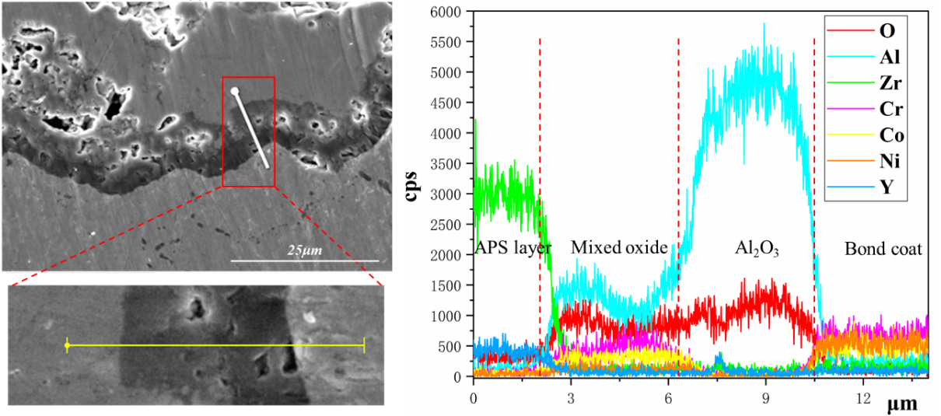

Fig. 4 The microstructure and element distribution of the columnar porous APS-SPS TBCs after 100 hours of oxidation at 1150 ℃.

It should be noted that during the oxidation process, the Al depletion area was not found as expected, which had been reported [18].

3.3 Effect of topcoat microstructure on TGO growth

The TGO thicknesses of the four kinds of APS-SPS TBCs were measured from SEM pictures of cross-sections of the samples after oxidation at 1150 ℃ for 10, 20, 30, 50, 100 and 200h, respectively. The average TGO thickness is calculated with reference to the following formula,

(2)

Fig. 5 shows the experimental data and fitting curves of TGO thickness after different oxidation times of the different TBCs. The oxidation kinetics of TGO thickness can be described by a parabolic law. The following formula is used to fit the growth process of TGO,

(3)

where is the thickness of the TGO, is a constant representing the TGO growth rate, *t* is oxidation time, and *c* is a constant.

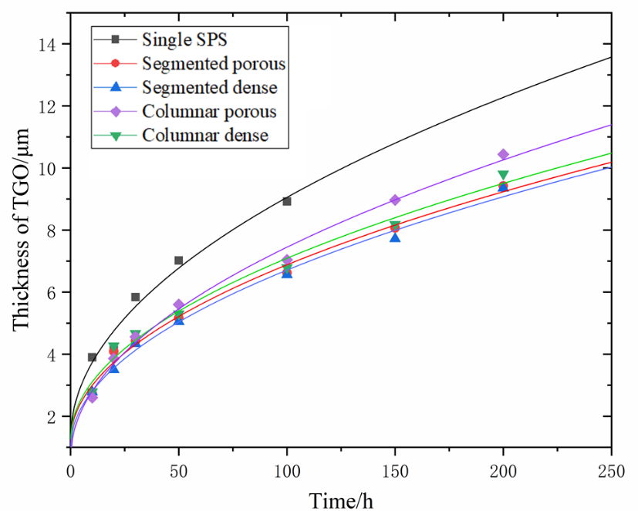

Fig. 5 TGO growth kinetics of single SPS and APS-SPS TBCs after isothermal oxidation at 1150 ℃.

**Table 2** TGO growth rate constants of different TBCs (c-columnar, s-segmented).

|  |  |  |  |  |  |
| --- | --- | --- | --- | --- | --- |
| Specimen type | Single SPS | c dense | c porous | s dense | s porous |
| / | 7.78×10-2 | 5.83×10-2 | 6.80×10-2 | 5.67×10-2 | 5.71×10-2 |

Oxygen is transported to the TC/BC interface through gas permeation and ionic diffusion [31]. As shown in Fig. 5, the difference of TGO thickness between different APS-SPS TBCs is not significant when the oxidation time is not long enough (≤ 100h). Since after a very brief initial period, the oxygen transport by diffusion is high enough to ensure oxide growth, the top layer has very little restriction on oxide growth rate [32]. As the oxidation time increases, the difference in TGO thickness between different TBCs increases. Table 2 lists the TGO growth rate constants of different TBCs, fitted with the Eq. (3). Compared with single SPS TBCs, the better oxidation resistance of APS-SPS TBCs is obvious. In this work, the lowest TGO growth rate constant of APS-SPS TBCs can be as low as 5.67×10-2, whereas the TGO growth rate constant of single SPS TBCs is 7.78×10-2. In previous research, the oxidation resistance at 1100°C of single 8YSZ TBC and LZO/8YSZ DCL TBCs sprayed by APS were tested [33], in which the oxidation kinetic of TGO thickness was also fitted by Eq. (3). The LZO layer reduces the TGO growth rate constant from 6.26×10-2 to 5.79×10-2. It was found that even the oxidation temperature is 50 ℃ higher, the lowest TGO growth rate constant of APS-SPS TBCs in this work is a little lower than that of single 8YSZ TBC and LZO/8YSZ DCL TBCs as reported, which means that the here used APS-SPS TBCs has better oxidation resistance which is of course also related to bond coat properties.

Under TBCs operating conditions, oxygen transport through the top coat through gas permeation is expected to dominate that by solid state diffusion, which means that gas permeation will dominate oxygen transport through the top coat over the entire operating temperature range of a TBC system [32]. On the other hand, according to the measured TGO thicknesses, the TGO of APS-SPS TBCs grows slower than that of both segmented and columnar APS-SPS TBCs. As the permeation rates through the topcoats are for thermally sprayed coatings typically much higher than the needed oxygen amount for the scale grow, the findings have to be further explained. Ceramic thermally sprayed coatings are bonded to metallic structures in most cases by a mechanical interlocking. There is hardly a true chemical bonding and so a small gap between ceramic topcoat and bond coat is expected. It is assumed that this gap allows easy access of oxygen from e.g. segmentation cracks to the whole bond coat surface for oxidation. That is different if the SPS topcoat is in contact to the splats of an APS intermediate layer. Here also a chemical bonding between SPS and the APS splats, both made out of YSZ, can be expected. If a segmentation crack or the region between two columns ends at such an APS splat, the oxygen atoms have to diffuse as ions through the splats to reach the crack network of the APS layer. Due to the low electronic conductivity, the ion diffusivity is limited and hence a reduction of the oxidation rate can be observed.

Porosity levels in the segments or the columns can lead to additional oxygen transport to the APS layer. As the segments show a lower density than the columns, the oxidation rates in segmented coatings are reduced. Also the difference between porous and dense segmented and columnar coatings (Table 2) can be explained by this assumption.

In addition, the thickness of mixed oxide layer can represent the oxidation resistance of TBCs to a certain extent. Fig. 6 shows the element distributions of the four kinds of APS-SPS TBCs after 200h oxidation. As can be seen, the oxide layer can be divided into two layers, in which the lower layer of oxide consists of dense alumina, and the outer layer is a mixed oxide mainly composed of chromium, cobalt and nickel rich oxides, which often form spinel type structures. The measured thicknesses of the mixed oxide layer and TGO after 200h oxidation are presented in Fig. 7. As mentioned in section 3.2, a dense aluminum oxide layer typically leads to a low oxidation rate of the TBC system, while the growth of the mixed oxide layer will eventually lead to early TBC failure. As shown in Fig. 7, the thickness of the mixed oxide layer of the columnar APS-SPS TBCs is higher than that of segmented APS-SPS TBCs, which further illustrated that segmented APS-SPS TBCs has slightly better oxidation resistance.

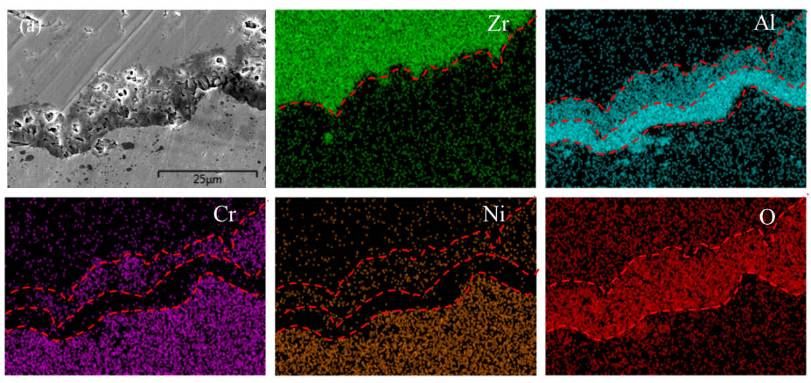

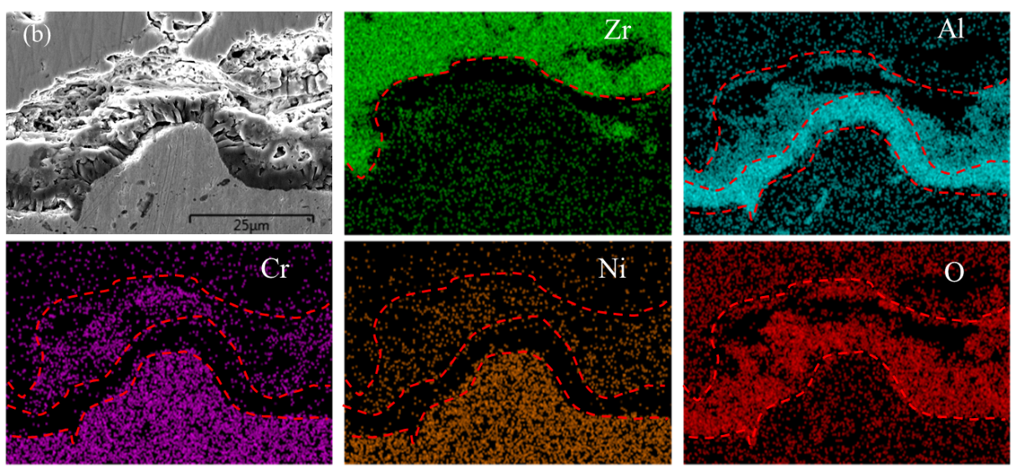

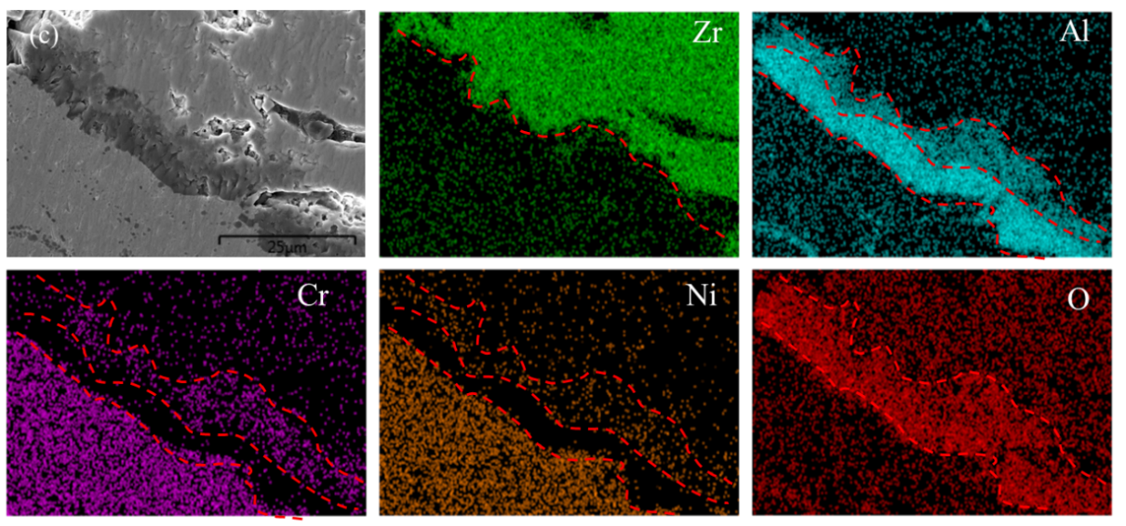

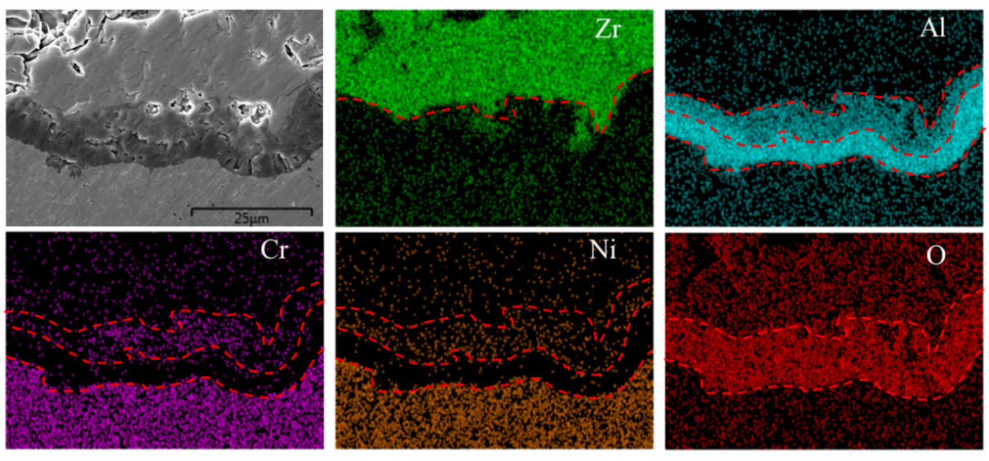

Fig. 6 The element distribution diagram of four kinds of APS-SPS TBCs after 200h oxidation at 1150 ℃: columnar: (a) dense, (b) porous, segmented: (c) dense, (d) porous.

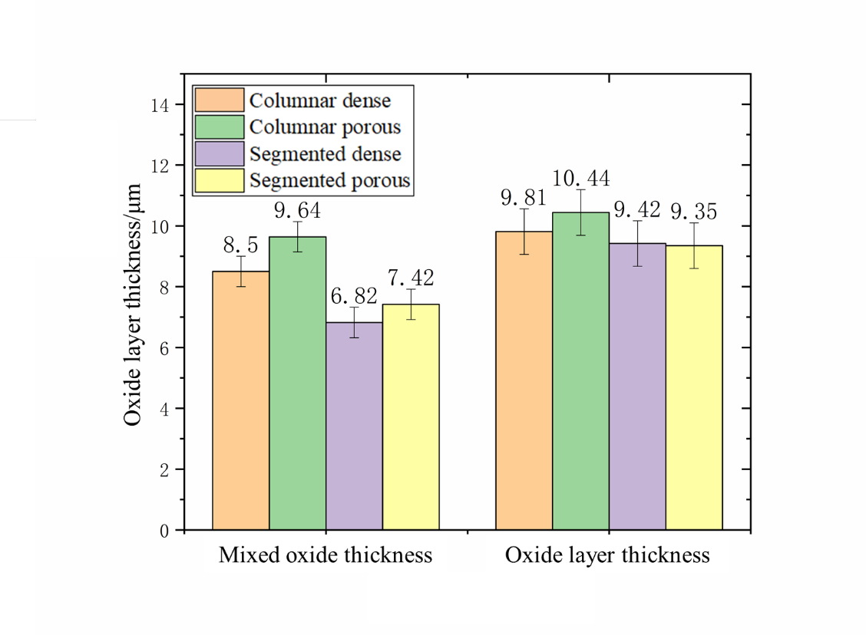

Fig. 7 The thickness of the mixed oxide layer and oxide layer after 200h oxidation at 1150 ℃.

Fig. 8 shows the proportion of mixed oxide in the total oxide layer. No mixed oxide was found in the cross sections of the oxide scale after oxidation for 30h. After oxidation for 50h, a continuous mixed oxide was observed for the first time. This might be due to a depletion of the aluminum content in the bond coat leading to the oxidation of other elements. As shown in Fig. 8, for APS-SPS even though the proportion of mixed oxides is different, a clear increase of the amount of mixed oxides over time is visible for all coatings. The growth rate of mixed oxides seems to increase with time. The formation of the transient oxides is controlled by different factors as diffusion rates through the alumina scale and stability range of the specific oxides. At the final stage of the oxidation, all elements except Ni and Co are depleted in the bond coat and fast growing spinels are formed.

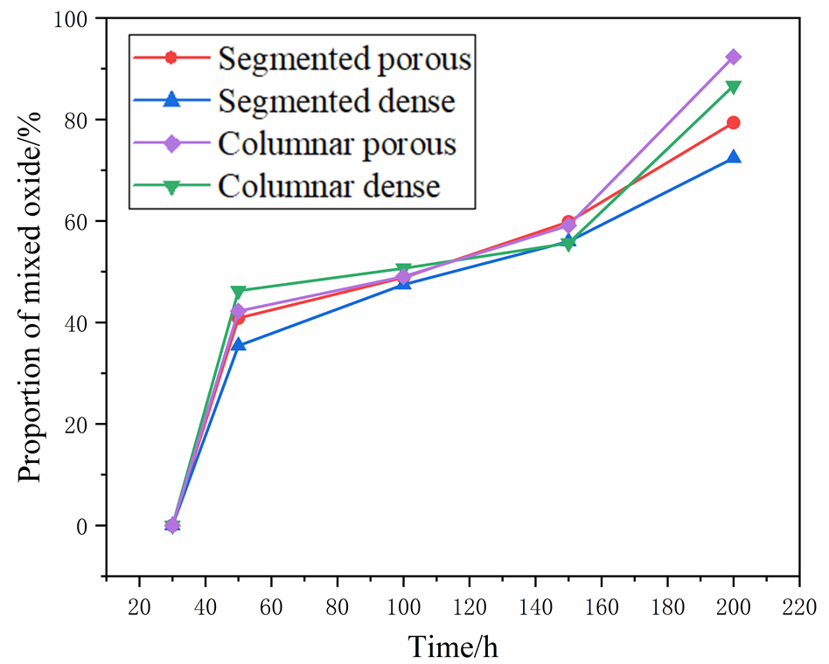

Fig. 8 The proportion of mixed oxide with oxidation time at 1150 ℃.

3.4 Effect of microstructures on oxidation life

The long-term oxidation lifetimes of different specimens at 1150 ℃ are shown in the Table 3. The oxidation lifetime of APS-SPS TBCs is about 300~400h. Compared with the oxidation kinetics of APS-SPS TBCs shown in Fig. 5, it can be concluded that the faster the growth rate of TGO, the shorter the lifetime of TBCs. The lifetime of columnar porous APS-SPS TBCs is shorter than that of other APS-SPS TBCs, due to the faster TGO growth and the larger growth stress. The segmented dense APS-SPS TBCs has the longest lifetime due to the lowest TGO growth rate.

**Table 3** Oxidation lifetime of different APS-SPS TBCs (c-columnar, s-segmented)

|  |  |  |  |  |
| --- | --- | --- | --- | --- |
| Specimen type | c dense | c porous | s dense | s porous |
| Lifetime/ h | 370 | 340 | 390 | 370 |
| TGO thickness at failure/ | 22.56 | 24.46 | 16.33 | 15.01 |

Photos of APS-SPS TBCs before and after oxidation lifetime tests are shown in Fig. 9. The failure of columnar APS-SPS TBCs is mainly caused by partial shedding, while the failure of segmented APS-SPS TBCs is mainly caused by warpage. The top coat of segmented APS-SPS TBCs is relatively complete after the test, but debonding caused by warpage occurs at the interface between the coating and the substrate which leads to the ultimate failure of TBCs.

It should be noted here that the size of the samples were rather small and so the transfer of the results to real component is not straightforward. Also the observed TGO thickness values at failure (Table 3) appear to be much larger than those found in larger samples.

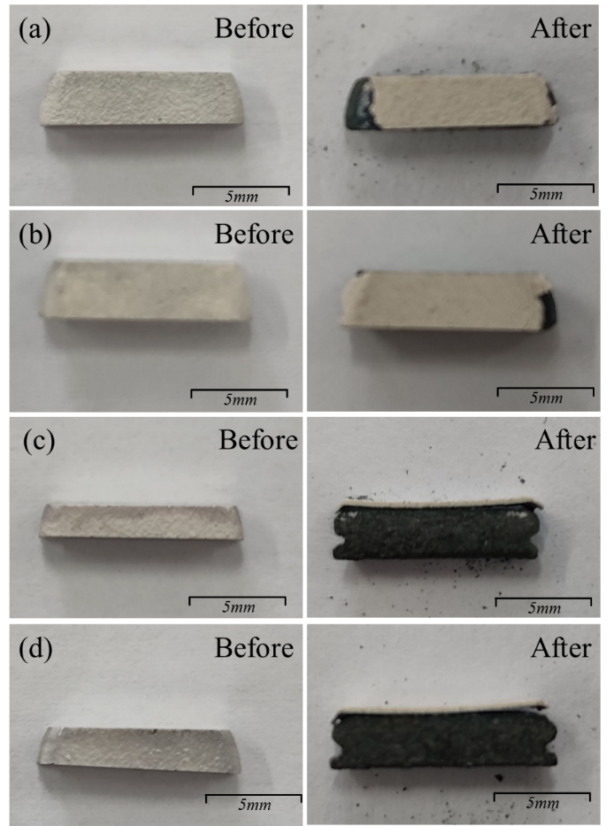

Fig. 9 Photos of APS-SPS TBCs before and after oxidation lifetime tests: (a) columnar dense, (b) columnar porous, (c) segmented dense, (d) segmented porous.

The lifetime of TBCs is affected by several factors, including (1) the strain tolerance and sintering resistance of the ceramic layer and its chemical composition, (2) the roughness of the ceramic layer-adhesive layer interface, (3) the oxide growth [34-38]. The lifetime results of the present investigation can be explained by an interplay of strain tolerance and oxide growth kinetics. Columnar APS-SPS TBCs have larger TGO thickness at failure, and this is due to their greater strain tolerance, even though it has been proved that the vertical cracked structure can also improve the strain tolerance and sintering resistance [39]. However, the columnar structure can probably increase the strain tolerance of the coating to a greater extent. In general, the lifetime of segmented APS-SPS TBCs is longer than that of columnar APS-SPS TBCs, and this is due to their slower TGO growth.

In view of the oxidation lifetime, segmented APS-SPS TBCs showed a better performance than the columnar APS-SPS TBCs. In addition, segmented dense APS-SPS TBCs had a longer lifetime than the segmented porous APS/SPS TBCs.

1. **Conclusions**

In this work, the oxidation behaviors and lifetime of four kinds of APS-SPS DCL TBCs with different microstructures were evaluated. The oxidation and failure mechanisms are discussed. The following conclusions can be drawn from this work.

(1) The developed APS-SPS DCL TBCs have good structural integrity and oxidation resistance. Comparisons showed that the APS-SPS DCL TBCs reveal a better oxidation resistance than the single layer SPS TBCs.

(2) In the long-term oxidation test of APS-SPS TBCs, the TGO can be divided into two layers, the mixed oxide and Al2O3 layer. The proportion of mixed oxide in the TGO showed varying growth rates.

(3) In terms of the oxidation rate and oxidation lifetime, segmented APS-SPS TBCs showed a better performance than the columnar APS-SPS TBCs. Among the four different APS-SPS TBCs, segmented dense APS-SPS TBCs with low vertical crack density has the best potential for industrial applications.

**Acknowledgement**

This work is supported by National Science and Technology Major Project (J2019-IV-0003-0070), the National Natural Science Foundation of China (12102320) and China Postdoctoral Science Foundation (2021M692571).

**Reference**

[1] R. Vaßen, H. Kaßner, A. Stuke, F. Hauler, D. Hathiramani, D. Stöver, Advanced thermal spray technologies for applications in energy systems, Surf. Coat. Tech. 202 (2008) 4432–4437.

[2] E. Bakan, R. Vaßen, Ceramic top coats of plasma-sprayed thermal barrier coatings: materials, processes, and properties, J. Therm. Spray. Technol. 26 (2017) 992–1010.

[3] N.P. Padture, M. Gell, E.H. Jordan, Thermal barrier coatings for gas-turbine engine applications, Science. 296 (2002) 280–284.

[4] W.W Zhang, G.R. Li, Q. Zhang, G.J. Yang, Comprehensive damage evaluation of localized spallation of thermal barrier coatings, J. Adv. Ceram. 6 (2017) 230-239.

[5] R. Vaßen, H. Kaßner, G. Mauer, D. Stöver, Suspension plasma spraying: process characteristics and applications, J. Therm. Spray. Technol. 19 (2010) 219–225.

[6] S. Mahade, N. Curry, S. Bjo¨rklund, N. Markocsan, P. Nyle´n, R. Vaßen, Functional performance of Gd2Zr2O7/YSZ multilayered thermal barrier coatings deposited by suspension plasma spray, Surf. Coat. Tech. 318(2017) 208-216.

[7] D.P. Zhou, O. Guillon, R. Vaßen, Development of YSZ thermal barrier coatings using axial suspension plasma spraying, Coatings. 7 (2017) 120.

[8] A. Guignard, G. Mauer, R. Vaßen, D. Stöver, Deposition and characteristics of submicrometer-structured thermal barrier coatings by suspension plasma spraying, J. Therm. Spray. Technol. 21 (2012) 416–424.

[9] M. Marr, D. Waldbillig, O. Kesler, The influence of process equipment on the properties of suspension plasma sprayed yttria-stabilized zirconia coatings, J. Therm. Spray. Technol. 22 (2013) 116–124.

[10] B. Bernard, A. Quet, L. Bianchi, A. Joulia, A. Malié, V. Schick, B. Rémy, Thermal insulation properties of YSZ coatings: suspension plasma spraying (SPS) versus electron beam physical vapor deposition (EB-PVD) and atmospheric plasma spraying (APS), Surf. Coat. Tech. 318 (2017) 122–128.

[11] A. Ganvir, N. Curry, S. Björklund, N. Markocsan, P. Nylén, Characterization of microstructure and thermal properties of YSZ coatings obtained by axial suspension plasma spraying (ASPS), J. Therm. Spray. Technol. 24 (2015) 1195–1204.

[12] S.Q. Tao, J.S. Yang, M.L. Zhai, F. Shao, X.H. Zhong, H.Y. Zhao, Y. Zhuang, J.X. Ni, W. Li, S.Y. Tao, Thermal stability of YSZ thick thermal barrier coatings deposited by suspension and atmospheric plasma spraying, Crystals. 40 (2020) 2731–2745.

[13] W. Algenaid, A. Ganvir, R.F. Calinas, J. Varghese, K.V. Rajulapati, S. Joshi, Influence of microstructure on the erosion behaviour of suspension plasma sprayed thermal barrier coatings, Surf. Coat. Tech. 375 (2019) 86–99.

[14] R. Vaßen, F. Träger, D. Stöver, New Thermal Barrier Coatings Based on Pyrochlore/YSZ Double-Layer Systems. Int. J. Appl. Ceram. Tec. 1 (2004) 351-361.

[15] C. Ren, Y.D. He, D.R. Wang, Cyclic oxidation behavior and thermal barrier effect of YSZ–(Al2O3/YAG) double-layer TBCs prepared by the composite sol–gel method, Surf. Coat. Tech. 206 (2011) 1461–1468.

[16] P.G. Lashmi, P.V. Ananthapadmanabhan, G. Unnikrishnan, S.T. Aruna, Present status and future prospects of plasma sprayed multilayered thermal barrier coating systems, J. Eur. Ceram. Soc. 40 (2020) 2731–2745.

[17] E. Bakan, D.E. Mack, G. Mauer, R. Mucke, R. Vaßen, Porosity–property relationships of plasma-sprayed Gd2Zr2O7/YSZ thermal barrier coatings, J. Am. Ceram. Soc. 98 (2015) 2647–2654.

[18] K.M. Doleker, Y. Ozgurluk, A.C. Karaoglanli, Isothermal oxidation and thermal cyclic behaviors of YSZ and double layered YSZ/La2Zr2O7 thermal barrier coatings (TBCs), Surf. Coat. Tech. 351 (2018) 78–88.

[19] S. Mahade, R. Li, N. Curry, S. Björklund, N. Markocsan, P. Nylén, Isothermal oxidation behavior of Gd2Zr2O7/YSZ multilayered thermal barrier coatings, Int. J. Appl. Ceram. Tec. 13 (2016) 443–450.

[20] D.P. Zhou, D.E. Mack, P. Gerald, O. Guillon, R. Vaßen, Architecture designs for extending thermal cycling lifetime of suspension plasma sprayed thermal barrier coatings, Ceram. Int. 45 (2019) 18471-18479.

[21] G. Mauer, R. Vaßen, Coatings with columnar microstructures for thermal barrier applications, Adv. Eng. Mater. 22 (2020) 1900988.

[22] M. Gupta, X.H. Li, N. Markocsan, B. Kjellman, Design of high lifetime suspension plasma sprayed thermal barrier coatings, J. Eur. Ceram. Soc. 40 (2020) 768-7779.

[23] M. Gupta, N. Markocsan, X.H. Li, B. Kjellman, Development of bondcoats for high lifetime suspension plasma sprayed thermal barrier coatings, Surf. Coat. Tech. 371 (2019) 366–377.

[24] L. Guo, G. Li, Z.L. Gan, Effects of surface roughness on CMAS corrosion behavior for thermal barrier coating applications, J. Adv. Ceram. 10 (2021) 472-481.

[25] N. Curry, Z. Tang, N. Markocsan, P. Nylén, Influence of bond coat surface roughness on the structure of axial suspension plasma spray thermal barrier coatings — thermal and lifetime performance, Surf. Coat. Tech. 268 (2015) 15–23.

[26] M. Gupta, N. Markocsan, X.H. Li, L. Östergren, Influence of bondcoat spray process on lifetime of suspension plasma-sprayed thermal barrier coatings, J. Therm. Spray. Technol. 27 (2018) 84–97.

[27] L. Guo, H. Xin, Z. Zhang, X.M. Zhang, F.X. Ye, Microstructure modification of Y2O3 stabilized ZrO2 thermal barrier coatings by laser glazing and the effects on the hot corrosion resistance, J. Adv. Ceram. 9 (2020) 232-242.

[28] R. Vaßen, E. Bakan, D. Mack, S. Schwartz-Lückge, D. Sebold, Y.J. Sohn, D.P. Zhou, O. Guillon, Performance of YSZ and Gd2Zr2O7/YSZ double layer thermal barrier coatings in burner rig tests, J. Eur. Ceram. Soc. 40 (2020) 480-490.

[29] W.F. Gale, T.C. Totemeir, Smithell Metal Reference Book, 8th Edition, Elsevier, Burlington, USA, 2008.

[30] Subhasisa Nath, Indranil Manna, Jyotsna Dutta Majumdar, Kinetics and mechanism of isothermal oxidation of compositionally graded yttria stabilized zirconia (YSZ) based thermal barrier coating, Corros. Sci. 88 (2014) 10–22.

[31] Y. Bai, C. Ding, H. Li, Z. Han, B. Ding, T. Wang, L. Yu, Isothermal oxidation behavior of supersonic atmospheric plasma-sprayed thermal barrier coating system, J. Therm. Spray Technol. 22 (2013) 1201–1209.

[32] A.C. Fox, T.W. Clyne, Oxygen transport by gas permeation through the zirconia layer in plasma sprayed thermal barrier coatings, Surf. Coat. Tech. 184 (2004) 311–321.

[33] W. Li, L. Yang, G. An, B. Cheng, L. Feng, Y. Zhang, Rare. Metal. Mat. Eng. 48(2019) 3527-3534

[34] A.G. Evans, D.R. Mumm, J.W. Hutchinson, G.H. Meier, F.S. Pettit, Mechanisms controlling the durability of thermal barrier coatings, Prog. Mater. Sci. 46 (2001) 505–553.

[35] M. Ahrens, S. Lampenscherf, R. Vaßen, D. Stöver, Sintering and creep processes in plasma-sprayed thermal barrier coatings, J. Therm. Spray. Technol. 13 (2004) 432–442.

[36] R. Vaßen, S. Giesen, D. Stöver, Lifetime of plasma-sprayed thermal barrier coatings: comparison of numerical and experimental results, J. Therm. Spray. Technol. 18 (2009) 835–845.

[37] H.E. Evans, Oxidation failure of TBC systems: an assessment of mechanisms, Surf. Coat. Tech. 206 (2011) 1512–1521.

[38] M. Gupta, K. Skogsberg, P. Nylén, Influence of topcoat-bondcoat interface roughness on stresses and lifetime in thermal barrier coatings, J. Therm. Spray. Technol. 23 (2014) 170–181.

[39] B.W. Lv, R. Mücke, D.P. Zhou, X.L. Fan, T.J. Wang, O. Guillon. R. Vaßen, A constitutive model for the sintering of suspension plasma‐sprayed thermal barrier coating with vertical cracks, J. Am. Ceram. Soc. 102 (2019) 6202–6212.